|  |
| --- |
| *Retrofitting towards climate neutrality* |
| **D6.8 First Virtual Reality 3D video and Release project video**  **Programme: HORIZON EUROPE**  **Grant agreement number: 101096522**  **Project acronym: Green Marine**  **Project title: Retrofitting towards climate neutrality**  **Prepared by: UoS and CMMI with the support of CalMac and the crew of MV Coruisk**  **Date: 22/11/2023**  **Report version: v1.0**   |  |  |  |  |  | | --- | --- | --- | --- | --- | |  |  |  |  |  | |
| **Funding acknowledgement**  **Funded by the European Union; funding from the European Union’s Horizon Europe research and innovation program under grant agreement No. 101096522**  **UK participation in Green Marine project is co-funded by Innovate UK funding scheme** |

|  |  |  |
| --- | --- | --- |
| **HISTORY OF CHANGES** | | |
| Version | Publication Date | Changes |
| 1.0 | [28/09/2023] | First draft |
| 1.0 | [15/11/2023] | Vessel visit to capture VR 360o video |
| 1.0 | [21/11/2023] | Review by reviewers on page 4 |
| 1.0 | [22/11/2023] | Final submission to SyGMa portal |

|  |  |
| --- | --- |
| **DETAILS** | |
| Grant Agreement No. | 101096522 |
| Project acronym | Green Marine |
| Project full title | Retrofitting towards climate neutrality |
| Dissemination level | Public |
| Due date of deliverable | M10 |
| Actual submission date | M10 |
| Deliverable name | First Virtual Reality 3D video and Release project video |
| Type | Report / Other |
| Status | Initial version |
| WP contributing to the deliverable | WP6 |
| Author(s) | Iraklis Lazakis (UoS), George Mallouppas (CMMI) |
| Other Contributor(s) | Oliver McKellar (CalMac) |
| Reviewer(s) | Elias Yfantis (CMMI), Yaseen Ahmed (UoS), Alex Cross (CalMac) |
| Keywords | Green Marine, YouTube channel, Project Video, Virtual Reality 360o video, Engine Room, Forward Engine Room, Aft Engine Room, HVAC. |

**Table of Contents**

1. Introduction 6

2. Green Marine YouTube channel 6

2.1 Green Marine project video 7

2.2 First Virtual Reality Video 7

3. Conclusions 9

# Introduction

The main objective of **Green Marine** is to significantly accelerate climate neutrality of water borne transport through retrofitting existing fleets with cost and emission control solutions. To support decision makers retrofitting protocols and a software tool catalogue that gathers knowledge will be developed and validated. We will demonstrate these tools and the innovative solutions aimed at carbon capture mineralization, which also aids in deacidifying our seas; energy savings for HVAC systems through air-reuse; carbon and water capture with membranes, and the use of excess engine heat to produce a syngas to save on fuel consumption. An ultra-sound technology will be tailored to suit vessels allowing air-reuse saving energy for HVAC systems and operated as pre-treatment enhancing a membrane carbon capture process. The Ca/Mg – alkali solvent capture process is capable of removing 75% of the CO2 from flue gases. All solutions will be demonstrated first on a land-based engine followed by the selection of the most suitable solution for a demonstration on a waterborne vessel. The (land-based) demonstrations will represent the operation of a majority of vessel engines. By developing retrofitting protocols, simulations of the solutions, data generated at the demonstrations a software catalogue tool will be developed. Through engagement activities this tool will gain more users and more knowledge, its value and effectiveness will increase for all users. The project aims to bring the different solutions to TRL 8. The demonstrations, the software tool catalogue, and the dissemination and exploitation activities ensure that project results will be replicated globally. The consortium consists of 10 partners from 7 countries with 4 research institute, 1 ship company, which will host a demo as end user and 5 SMEs.

# Green Marine YouTube channel

The Green Marine consortium has created a dedicated YouTube channel to host videos that will disseminate the activities to the general public and other relevant stakeholders.

The link of the Green Marine YouTube channel is:

<https://www.youtube.com/@GreenMarineproject/featured>

## 2.1 Green Marine project video

The Green Marine project video has been posted on the YouTube channel (see Figure 1).

[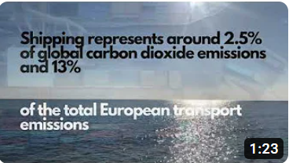](https://www.youtube.com/watch?v=YcegprHETwI)

**Figure 1.** Green Marine project video.

## 2.2 First Virtual Reality Video

The selected CalMac vessel is shown in Figure 2 (MV Coruisk). The Green Marine partners visited the vessel on the 15th November 2023, in particular the aft and forward engine rooms and HVAC (see Figure 3 and Figure 4). CalMac has recently changed its policy regarding public distribution of images/videos inside the vessel, including the engine rooms. The VR videos will be used by the Green Marine consortium for an effective design of the proposed Green Marine technologies.

**Figure 2.** MV Coruisk, the vessel selected by CalMac for the on-board demonstrations.

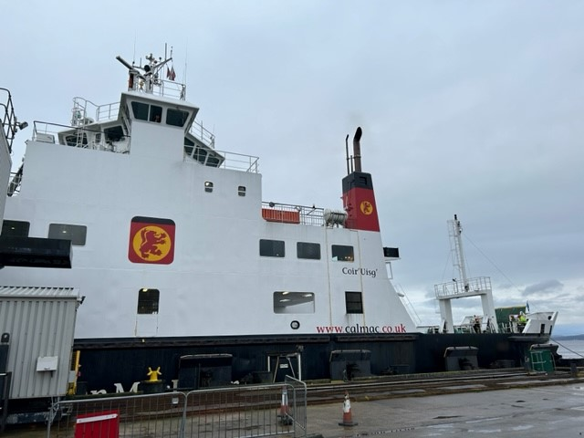

**Figure 3.** MV Coruisk alongside at the time of the site visit

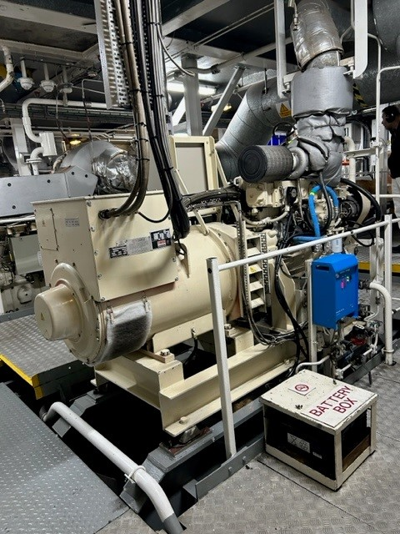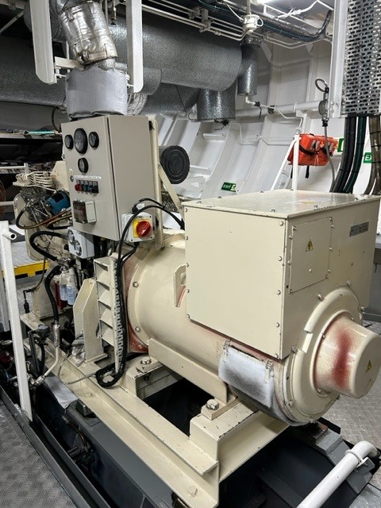

**Figure 4.** MV Coruisk auxiliary diesel generator within fwd engine room.

As such the first virtual reality 360o video shows a user using CMMI’s Virtual Reality headsets visualising, the engine rooms (aft and forward) and HVAC room. The aft engine room contains the selected auxiliary engine to be used for the on-board demonstrations (see Figure 5).

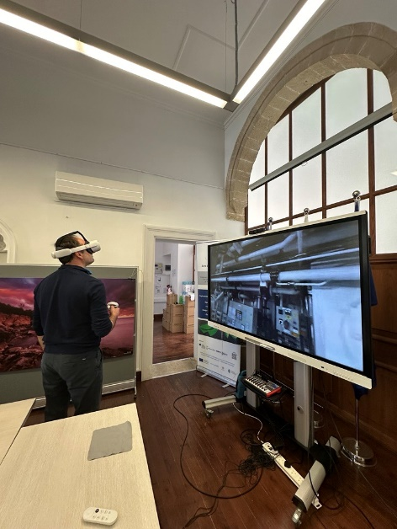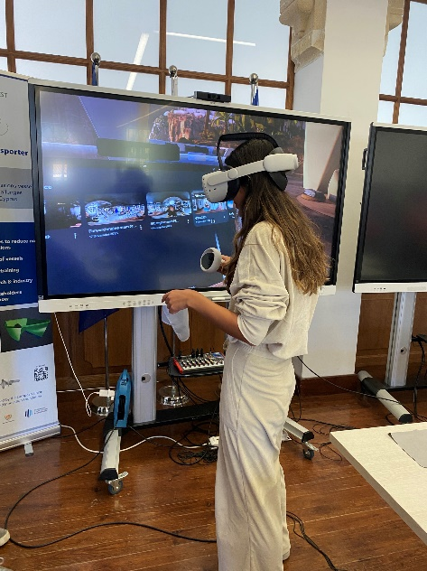

**Figure 5.** Green Marine first Virtual Reality 360o video on-board the engine room of selected CalMac vessel MV Coruisk. Demonstration of videos via CMMI’s virtual reality headset (Larnaka at CMMI House premises).

# Conclusions

The official Green Marine YouTube channel has been set up and project video has been posted. The first virtual reality video is not shared publicly due to recent policy changes by CalMac. These activities are part of deliverable D6.8, “First Virtual Reality 3D video and Release project video”. Note that the 360o videos are available to the Green Marine consortium to enable with the relevant activities. A second virtual reality video (D6.9) is planned to be submitted on M30.